Prime Factor Tree

Draw a prime factor tree for each number then express the number as a product of its prime factors.
1) 80 2) 52

3) 72 4) 99

5) 60 6) 36

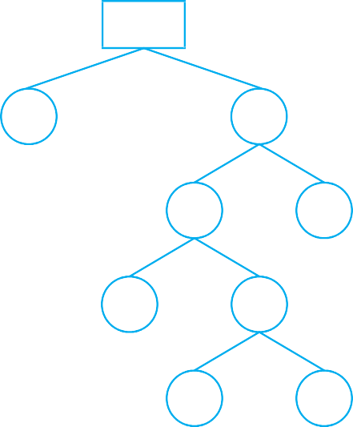
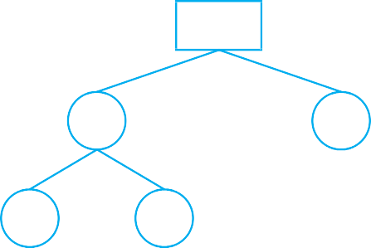
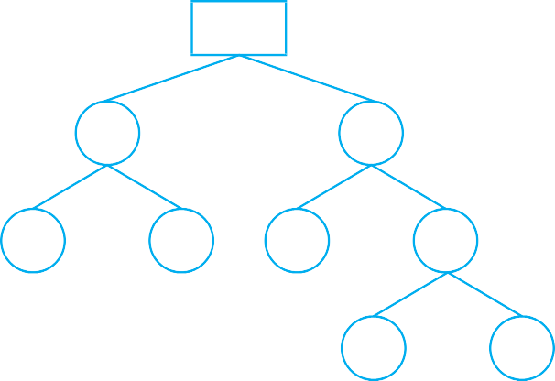
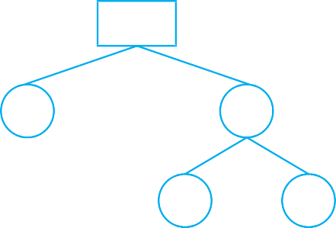
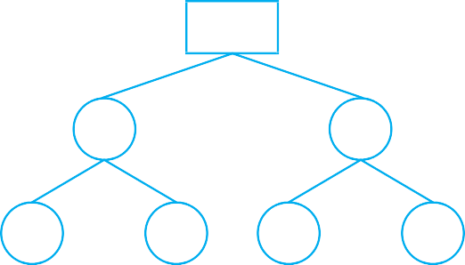
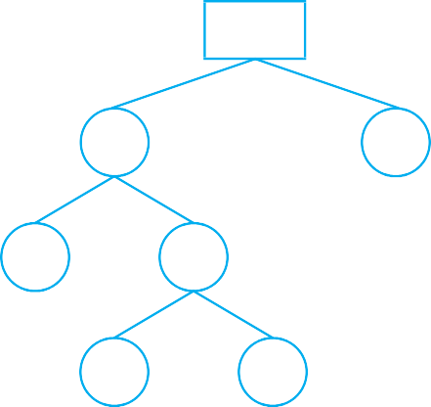
Answer Key

Prime Factor Tree

Draw a prime factor tree for each number. (diagrammatic representation may vary)

1) 80 2) 52

80 52

2 40 26 2

20 2 13 2

2 10

5 2

3) 72 4) 99

72 99

9 8 3 33

3 3 2 4 3 11

2 2

5) 60 6) 36

60 36

6 10 18 2

2 3 5 2 2 9

3 3

